
NEW-GEN AI PROJECT
A project report submitted in partial fulfilment of the requirements of 2nd year
of 2nd- semester of
BACHELOR OF TECHNOLOGY
In
COMPUTER SCIENCE ENGINEERING
( ARTIFICIAL INTELLIGENCE AND DATA SCIENCE )
SYED AFRIN (24ME1A54B1)
R.SUMASREE (24ME1A54A2)
T.HARSHINI(24ME1A54B6)
N.VIJAYA(25ME5A5408)

DEPARTMENT OF ARTIFICIAL INTELLIGENCE AND DATA SCIENCE
RAMACHANDRA COLLEGE OF ENGINEERING
(AUTONOMOUS)
(Approved by AICTE, Affiliated to JNTUK, Kakinada) Accredied by NBA, NAAC A+
NH-16 Bypass, Vatluru(V), Eluru – 534007, Eluru Dist., A.P 20252026

CERTIFICATE

This is to certify that the “AI MCQ DISTRACTOR
GENERATOR” submitted by SYED AFRIN (24ME1A54B1),
R.SUMASREE (24ME1A54A2) T.HARSHINI (24ME1A54B6),
N.VIJAYA(25ME5A5408)the project done by and submitted during 2025-2026 academic year in partial fulfilment of the requirements in Electronics and Communication Engineering to the Ramachandra College of Engineering, Eluru affiliated to JNTUK, Kakinada is a record of bonafide work carried out during the AY 2025-26. .

Under the Guidance of : Head of the department

Mr. P. Pavan Kumar , Mr. P.Sudhakar
Trainer
Training co-ordinators
Mrs. P.Neeraja

INDEX
S.NO | CONTENTS | PAGE NO:
1. | ABSTRACT | 4
2. | INTRODUCTION | 5
3. | PROPOSED SYSTEM | 6 - 8
4. | METHODOLOGY | 9 – 10
5. | SOFTWARE ENVIRONMENT | 11 – 12
6. | IMPLEMENTATION | 13 – 16
7. | CODE | 17 – 23
8. | RESULTS | 24 – 28
9. | CONCLUSION | 29 – 30

ABSTRACT

Artificial Intelligence is transforming the education sector by automating tasks that traditionally required significant human effort. One such task is the creation of multiple-choice questions (MCQs), particularly the generation of distractors (incorrect but plausible options). Writing effective distractors is time-consuming and requires subject expertise.
The AI MCQ Distractor Generator is a system designed to automatically generate meaningful distractors for MCQ questions using Natural Language Processing (NLP) techniques. The system takes a question and its correct answer as input and generates several relevant incorrect options that appear plausible to students.
The proposed system uses AI techniques such as semantic similarity, word embeddings, and language models to identify related words or concepts that can serve as distractors. This helps teachers, educators, and content creators quickly generate high-quality MCQs for exams, quizzes, and learning platforms.
The system improves productivity, reduces manual effort, and maintains question quality. It can be integrated into e-learning platforms, assessment systems, and digital education tools to support automated question generation.

INTRODUCTION

Multiple-choice questions are widely used in educational institutions, online learning platforms, and competitive examinations. They provide an efficient way to assess student knowledge because they are easy to grade and can cover a wide range of topics.
However, creating good MCQs requires more than just writing a question and a correct answer. The distractors (incorrect options) must be carefully designed to be believable and relevant to the question. Poorly designed distractors make the question too easy and reduce the effectiveness of the assessment.
Artificial Intelligence and Natural Language Processing offer solutions to automate this process. By analyzing the meaning of words and their relationships, AI can generate alternative answers that are related to the correct answer but still incorrect.
The AI MCQ Distractor Generator aims to support educators by automatically generating distractors based on linguistic and semantic relationships. The system can process text, identify key concepts, and generate plausible alternatives.
The goal of this project is to design and implement an intelligent system that assists teachers and exam creators in building high-quality MCQ assessments quickly and efficiently.

PROPOSED SYSTEM

The proposed system introduces an intelligent AI-based solution for automatically generating distractors for multiple-choice questions. Traditional MCQ creation is a time-consuming process that requires significant effort from educators to design effective distractors that challenge students. The proposed system aims to automate this task while maintaining high educational quality.

Overview of the Proposed System
The proposed system uses Artificial Intelligence and Natural Language Processing techniques to analyze questions and generate relevant distractors. Unlike manual methods, the system can produce multiple distractor options instantly while maintaining contextual relevance to the question.
The main objective of the proposed system is to assist teachers, educators, and examination boards in generating high-quality MCQ assessments efficiently.

Key Features of the Proposed System 1. Automated Distractor Generation
The system automatically generates plausible distractors based on the correct answer and the context of the question. This significantly reduces the time required to create MCQ questions manually.
- Context-Aware AI Model
The AI model understands the semantic meaning of the question and produces distractors that are closely related to the topic. This improves the quality of the distractors and makes them more effective for evaluating student knowledge.
- Difficulty Level Control
The system can adjust the complexity of distractors based on the desired difficulty level. Easy distractors may include obviously incorrect options, while harder distractors may be more closely related to the correct answer.
- User-Friendly Interface
The proposed system includes a simple and intuitive interface that allows users to input questions and receive generated distractors quickly. Teachers can edit or regenerate distractors as needed.
- Database Storage
The system maintains a database that stores generated MCQs. This allows users to reuse, modify, or organize questions for future assessments.
- Multi-Subject Support
The proposed system can support multiple academic domains such as science, mathematics, history, and language subjects. This flexibility makes it suitable for various educational institutions.

Advantages of the Proposed System
The proposed system offers several advantages compared to traditional MCQ creation methods.
- Time Efficiency: Generates distractors within seconds.
- Consistency: Maintains uniform quality across questions.
- Scalability: Can generate large numbers of MCQs for exams or practice tests.
- Reduced Human Effort: Minimizes manual work for teachers.
- Improved Assessment Quality: Produces meaningful distractors that effectively test student understanding.

System Design Considerations
While designing the proposed system, several factors are considered to ensure effectiveness:
- Maintaining semantic similarity between distractors and the correct answer.
- Avoiding duplicate or obviously incorrect options.
- Ensuring grammatical correctness and readability.
- Supporting integration with existing e-learning platforms or examination systems.

Future Enhancements
The proposed system can be further improved by incorporating additional advanced features such as:
- Integration with learning management systems (LMS)
- Adaptive learning capabilities
- Automatic question generation along with distractors
- Support for multiple languages
- Real-time feedback for educators
These enhancements would expand the usefulness of the system in modern digital education environments.

METHODOLOGY

Overview of Methodology
The methodology of the AI MCQ Distractor Generator focuses on using Natural Language Processing (NLP) and Generative Artificial Intelligence techniques to generate plausible distractor options for a given question. The system follows a sequence of steps that include input processing, semantic analysis, distractor generation, filtering, and final output generation. These steps ensure that the generated distractors are relevant, grammatically correct, and conceptually related to the given question.

Data Input and Preprocessing
The first step in the methodology is collecting input from the user. The system accepts two main inputs: the question text and the correct answer. Once the input is received, preprocessing techniques are applied to clean and standardize the text. This process may include removing unnecessary symbols, converting text into lowercase, tokenizing the sentence, and identifying important keywords.
Preprocessing helps the system understand the structure of the question and identify the key concepts related to the correct answer. This step improves the accuracy of distractor generation by ensuring that the AI model receives clear and structured input.

Semantic Analysis
After preprocessing, the system performs semantic analysis using Natural Language Processing techniques. In this stage, the AI model analyzes the meaning of the question and the correct answer. Word embeddings, contextual understanding, and language models help the system understand relationships between words and concepts.
Semantic analysis ensures that the generated distractors are closely related to the correct answer but not identical. For example, if the

correct answer is a scientific term, the system will generate other terms from the same domain that may confuse students if they are not fully familiar with the concept.

Distractor Generation using Generative AI
The core component of the system is the distractor generation module. This module uses a generative AI model, such as a transformer-based language model, to create alternative answer options. The model is trained on large text datasets and can generate human-like text responses.
Based on the question context and correct answer, the AI model produces several candidate distractors. These distractors are generated by predicting words or phrases that are semantically related to the topic but do not match the correct answer. The generative approach allows the system to produce diverse and meaningful distractors rather than random incorrect answers

SOFTWARE ENVIRONMENT

Overview
The software environment of the AI MCQ Distractor Generator includes the tools, programming languages, frameworks, and libraries used to design and implement the system. A well-defined software environment ensures that the system runs efficiently and supports the AI-based functionalities required for distractor generation.

Programming Language
The primary programming language used for developing the system is Python. Python is widely used in artificial intelligence and machine learning projects because of its simplicity, readability, and large ecosystem of libraries. Python provides powerful support for natural language processing, data analysis, and machine learning, making it suitable for building the AI MCQ distractor generator.
Python also enables rapid development and easy integration with AI models and APIs. Its extensive community support ensures the availability of resources and documentation for implementing advanced AI techniques.

AI and NLP Libraries
Several AI and Natural Language Processing libraries are used in the system to support text analysis and distractor generation. Libraries such as Transformers, NLTK (Natural Language Toolkit), and spaCy help in text preprocessing, tokenization, semantic analysis, and language understanding.
The Transformers library provides access to powerful pre-trained language models that can generate context-aware text. NLTK and spaCy help in linguistic analysis and keyword extraction, which are essential for understanding the structure and meaning of the input question.

Development Framework
For building the user interface and integrating AI functionalities, frameworks such as Streamlit or Flask can be used. Streamlit is particularly suitable for AI projects because it allows developers to create interactive web applications quickly with minimal coding.
The framework helps create input fields for the question and correct answer, display generated distractors, and provide an easy-to-use interface for educators or users.

Database and Storage
The system may use a lightweight database such as SQLite or filebased storage to save generated questions and distractors. This allows users to store previously generated MCQs for later use.

Development Tools
The system can be developed using integrated development environments (IDEs) such as Visual Studio Code, PyCharm, or Jupyter Notebook. These tools provide features like debugging, code completion, and project management, which help developers write efficient and error-free code.

System Requirements
The AI MCQ Distractor Generator requires a computer system with sufficient processing power and memory to run AI models. A typical system with a modern processor, at least 8 GB RAM, and internet connectivity is sufficient for running the application and accessing AI APIs if required.

IMPLEMENTATION

The implementation of the AI MCQ Distractor Generator focuses on automatically generating meaningful and contextually relevant distractors (incorrect answer choices) for multiple-choice questions using Artificial Intelligence techniques. The system integrates Natural Language Processing (NLP) models, machine learning algorithms, and a user-friendly interface to assist educators in creating highquality MCQ assessments.

System Architecture
The system follows a modular architecture consisting of multiple components that work together to generate distractors. The major components include the input module, preprocessing module, AI generation module, distractor filtering module, and output interface.
1. Input Module
The input module allows users (teachers or exam creators) to enter the required information such as the question, correct answer, and optional context or subject domain. The input can be provided through a web interface or application interface. The system ensures that the input text is grammatically structured and suitable for processing.
- Preprocessing Module
The preprocessing stage prepares the text for AI analysis. Natural Language Processing techniques are applied to clean and normalize the input text. This process includes:
  - Tokenization o Stop word removal o Lemmatization or stemming o Part-of-speech tagging
  - Named entity recognition
These techniques help the system understand the grammatical structure and semantic meaning of the input question and correct answer.
- AI Generation Module
The core component of the system is the AI model used for generating distractors. Large Language Models (LLMs) or transformer-based models such as GPT-based architectures or BERT-based frameworks can be utilized. The model analyzes the context of the question and generates several plausible but incorrect answer options.
The AI model is trained using educational datasets, question banks, and structured text corpora to ensure that generated distractors are semantically related to the correct answer but still incorrect.
4. Distractor Filtering and Ranking Module
Not all generated distractors are suitable for educational use. Therefore, a filtering mechanism is implemented to remove lowquality distractors. The system evaluates distractors based on: o Semantic similarity o Difficulty level o Grammatical correctness o Relevance to the question
Ranking algorithms select the top distractors that appear most convincing to students while still being incorrect.
5. Output Interface
The final distractors are displayed to the user through the output interface. Typically, the system generates three or four distractor options along with the correct answer to form a complete multiple-choice question. Users can review, edit, or regenerate distractors if necessary.

Technologies Used
The AI MCQ Distractor Generator can be implemented using modern technologies including:
- Programming Language: Python
- AI/NLP Libraries: Transformers, NLTK, SpaCy, TensorFlow, or PyTorch
- Backend Framework: Flask or Django
- Frontend Interface: HTML, CSS, JavaScript or React
- Database: MySQL or MongoDB for storing generated questions and datasets
These technologies enable efficient processing of text and seamless integration of AI capabilities.

Workflow of the System
The implementation workflow of the system includes the following steps:
- User enters a question and the correct answer.
- The system preprocesses the input text using NLP techniques.
- The AI model analyzes the semantic structure of the question.
- Multiple distractor candidates are generated.
- The filtering module removes irrelevant or duplicate distractors.
- The system selects the best distractors and presents them to the user.
- The final MCQ is displayed or stored in the database.

Testing and Evaluation
The system is tested using multiple educational datasets to ensure the quality of generated distractors. Evaluation metrics include:
- Semantic similarity score
- Human expert evaluation
- Student confusion rate
- Accuracy and grammatical correctness
The testing process ensures that distractors are realistic, meaningful, and suitable for assessment purposes.

CODE

import streamlit as st
from groq import Groq
import json
import re
import random
import concurrent.futures

# ─── YOUR GROQ API KEY HERE ────────────────────────────────────────────────────
GROQ_API_KEY = "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"

# ─── Page Config ───────────────────────────────────────────────────────────────
st.set_page_config(
page_title="MCQ Distracter Generator",
page_icon="",
layout="wide"
)

# ─── Session State ─────────────────────────────────────────────────────────────
if "dark_mode" not in st.session_state:
st.session_state.dark_mode = True
if "saved_questions" not in st.session_state:
st.session_state.saved_questions = []
if "last_results" not in st.session_state:
st.session_state.last_results = []
if "num_questions" not in st.session_state:
st.session_state.num_questions = 1
if "form_reset_key" not in st.session_state:
st.session_state.form_reset_key = 0

# ─── CSS ───────────────────────────────────────────────────────────────────────
def inject_css(dark: bool):
if dark:
bg = "#0e0a1a"
surface = "#160f2a"
surface2 = "#1e1535"
border = "#3b2a6e"
text = "#f0eaff"
muted = "#9070c0"
accent = "#a855f7"
accent2 = "#7c3aed"
opt_bg = "#1a1030"
opt_hover = "#231545"
label_col = "#b08ae0"
save_bg = "#1a0f2e"
save_bdr = "#4a2a7a"
save_col = "#c084fc"
panel_bg = "#120a22"
num_bg = "#1e1535"
num_bdr = "#4a2a7a"
else:
bg = "#faf5ff"
surface = "#ffffff"
surface2 = "#f3e8ff"
border = "#d8b4fe"
text = "#2e1065"
muted = "#7c3aed"
accent = "#9333ea"
accent2 = "#7c3aed"
opt_bg = "#fdf4ff"
opt_hover = "#f3e8ff"
label_col = "#6b21a8"
save_bg = "#faf5ff"
save_bdr = "#c084fc"
save_col = "#9333ea"
panel_bg = "#faf5ff"
num_bg = "#f3e8ff"
num_bdr = "#d8b4fe"

st.markdown(f"""
<style>
@import url('https://fonts.googleapis.com/css2?family=Space+Grotesk:wght@400;500;600;700&family=JetBrains+Mono:wght@400;500&display=swap');

html, body, [data-testid="stAppViewContainer"], [data-testid="stApp"] {{
background-color: {bg} !important;
color: {text} !important;
font-family: 'Space Grotesk', sans-serif !important;
}}
[data-testid="stSidebar"] {{ display: none !important; }}
header[data-testid="stHeader"] {{ background: transparent !important; }}
[data-testid="stToolbar"] {{ display: none; }}
.main .block-container {{ padding: 1.5rem 2rem 4rem !important; max-width: 100% !important; }}
#MainMenu, footer {{ visibility: hidden; }}

.mcq-header {{ text-align: center; margin-bottom: 2rem; }}
.mcq-badge {{
display: inline-block;
background: {accent}18; border: 1px solid {accent}44; color: {accent};
font-family: 'JetBrains Mono', monospace; font-size: 11px;
letter-spacing: 3px; text-transform: uppercase;
padding: 5px 16px; border-radius: 100px; margin-bottom: 12px;
}}
.mcq-title {{
font-family: 'Space Grotesk', sans-serif !important;
font-size: clamp(1.8rem, 4vw, 2.8rem); font-weight: 700;
letter-spacing: -1.5px; line-height: 1.05; margin-bottom: 6px;
background: linear-gradient(135deg, {accent}, {accent2});
-webkit-background-clip: text; -webkit-text-fill-color: transparent;
background-clip: text;
}}
.mcq-sub {{ color: {muted}; font-size: 15px; line-height: 1.6; }}

label, .stTextInput label, .stTextArea label, .stNumberInput label {{
font-size: 13px !important; letter-spacing: 1.5px !important;
text-transform: uppercase !important; color: {label_col} !important;
font-family: 'JetBrains Mono', monospace !important;
}}

.stTextInput input, .stTextArea textarea, .stNumberInput input {{
background: {surface2} !important; border: 1px solid {border} !important;
border-radius: 10px !important; color: {text} !important;
font-family: 'Space Grotesk', sans-serif !important; font-size: 20px !important;
}}
.stTextInput input:focus, .stTextArea textarea:focus, .stNumberInput input:focus {{
border-color: {accent} !important; box-shadow: 0 0 0 3px {accent}28 !important;
}}

.stButton > button {{
width: 100%;
background: linear-gradient(135deg, {accent}, {accent2}) !important;
color: white !important; border: none !important; border-radius: 10px !important;
font-family: 'Space Grotesk', sans-serif !important; font-weight: 700 !important;
font-size: 16px !important; padding: 12px 0 !important; transition: all 0.2s !important;
}}
.stButton > button:hover {{
opacity: 0.9 !important; box-shadow: 0 8px 24px {accent}44 !important;
transform: translateY(-1px) !important;
}}

.q-block {{
background: {surface}; border: 1px solid {border}; border-radius: 22px;
padding: 36px 40px; margin-bottom: 32px;
}}
.q-block-header {{
font-family: 'JetBrains Mono', monospace; font-size: 14px; font-weight: 700;
color: {accent}; text-transform: uppercase; letter-spacing: 1.5px;
margin-bottom: 18px; padding-bottom: 14px; border-bottom: 1px solid {border};
}}

.opt-card {{
background: {opt_bg}; border: 1px solid {border}; border-radius: 16px;
padding: 24px 30px; display: flex; align-items: center; gap: 20px;
margin-bottom: 16px; transition: all 0.2s;
}}
.opt-card:hover {{ background: {opt_hover}; border-color: {accent}66; }}
.opt-card.correct {{ background: {accent}15; border-color: {accent}66; }}
.opt-letter {{
min-width: 52px; height: 52px; border-radius: 12px;
background: {surface2}; border: 1px solid {border};
display: flex; align-items: center; justify-content: center;
font-family: 'JetBrains Mono', monospace; font-weight: 700; font-size: 20px;
color: {accent}; flex-shrink: 0;
}}
.opt-letter.correct-letter {{ background: {accent}22; border-color: {accent}; color: {accent}; }}
.opt-text {{ font-size: 20px; color: {text}; line-height: 1.7; }}
.correct-badge {{
font-size: 11px; text-transform: uppercase; letter-spacing: 1px;
color: {accent}; margin-left: auto; white-space: nowrap;
}}

.result-title {{ font-family: 'Space Grotesk', sans-serif; font-size: 26px; font-weight: 700; color: {text}; margin-bottom: 10px; }}
.result-sub {{ font-size: 15px; color: {muted}; margin-bottom: 24px; }}

.q-box {{
background: {surface2}; border: 1px solid {border}; border-radius: 14px;
padding: 28px 32px; margin-bottom: 24px; font-size: 20px; color: {text}; line-height: 1.8;
}}
.q-box-label {{ font-size: 12px; text-transform: uppercase; letter-spacing: 1.5px; color: {muted}; margin-bottom: 8px; }}

.exp-box {{ background: {accent}0e; border: 1px solid {accent}33; border-radius: 16px; padding: 26px 32px; margin-top: 22px; }}
.exp-label {{ font-size: 12px; text-transform: uppercase; letter-spacing: 1.5px; color: {accent}; margin-bottom: 8px; }}
.exp-text {{ font-size: 17px; color: {muted}; line-height: 1.9; }}

.panel-title {{
font-family: 'Space Grotesk', sans-serif;
font-size: 18px; font-weight: 700; color: {text};
margin-bottom: 20px;
}}

.saved-card {{
background: {save_bg}; border: 1px solid {save_bdr}; border-radius: 14px;
padding: 18px 20px; margin-bottom: 14px;
}}
.saved-num {{ font-size: 11px; text-transform: uppercase; letter-spacing: 1.5px; color: {save_col}; margin-bottom: 6px; }}
.saved-q {{ font-size: 15px; font-weight: 500; margin-bottom: 8px; color: {text}; line-height: 1.5; }}
.saved-opt {{ font-size: 13px; color: {muted}; margin-bottom: 4px; }}

.empty-state {{
text-align: center; padding: 2rem 1rem; opacity: 0.4;
font-size: 13px; color: {muted};
}}

.parallel-badge {{
display: inline-block;
background: {accent}22; border: 1px solid {accent}55;
color: {accent}; font-size: 11px; border-radius: 6px;
padding: 3px 10px; letter-spacing: 1px; text-transform: uppercase;
margin-bottom: 12px;
}}

hr {{ border-color: {border} !important; margin: 16px 0 !important; }}
</style>
""", unsafe_allow_html=True)

# ─── Generate Distractors (single) ────────────────────────────────────────────
def generate_distractors(index: int, question: str, correct_answer: str, subject: str):
client = Groq(api_key=GROQ_API_KEY)
prompt = f"""You are an expert MCQ creator for educational assessments.

Subject: {subject}
Question: {question}
Correct Answer: {correct_answer}

Generate exactly 3 DISTRACTORS (wrong answer options).

Rules:
1. Plausible and logical — not obviously wrong
2. Similar length and style to the correct answer
3. Target common misconceptions
4. Must be CLEARLY WRONG (not partially correct)
5. Do NOT repeat or paraphrase the correct answer

Return ONLY a JSON object (no markdown, no extra text):
{{
"distractors": ["First wrong option", "Second wrong option", "Third wrong option"],
"explanation": "Brief explanation of why these distractors are pedagogically effective"
}}"""

response = client.chat.completions.create(
model="llama-3.3-70b-versatile",
messages=[{"role": "user", "content": prompt}],
max_tokens=1000,
temperature=0.7
)
text = response.choices[0].message.content.strip()
text = re.sub(r'```json|```', '', text).strip()
data = json.loads(text)

distractors = data.get("distractors", [])
all_options = distractors + [correct_answer.strip()]
random.shuffle(all_options)

return index, {
"question": question.strip(),
"correct_answer": correct_answer.strip(),
"subject": subject,
"options": all_options,
"labels": ["A", "B", "C", "D"],
"explanation": data.get("explanation", ""),
"error": None
}

def generate_all_parallel(questions_data, subject_val):
results = [None] * len(questions_data)
errors = {}

with concurrent.futures.ThreadPoolExecutor(max_workers=min(len(questions_data), 10)) as executor:
futures = {
executor.submit(generate_distractors, i, q, a, subject_val): i
for i, (q, a) in enumerate(questions_data)
}
for future in concurrent.futures.as_completed(futures):
i = futures[future]
try:
idx, result = future.result()
results[idx] = result
except Exception as e:
errors[i] = str(e)
results[i] = {
"question": questions_data[i][0],
"correct_answer": questions_data[i][1],
"subject": subject_val,
"options": [],
"labels": ["A", "B", "C", "D"],
"explanation": "",
"error": str(e)
}

return results, errors

# ─── Main App ──────────────────────────────────────────────────────────────────
def main():
dark = st.session_state.dark_mode
inject_css(dark)

# Theme toggle
t1, t2 = st.columns([10, 1])
with t2:
icon = "☀️" if dark else ""
if st.button(icon, key="theme_btn"):
st.session_state.dark_mode = not dark
st.rerun()

left_col, right_col = st.columns([3, 2], gap="large")

# ════════════════════════════
# LEFT — Main Generator
# ════════════════════════════
with left_col:
st.markdown("""
<div class="mcq-header">
<div class="mcq-badge">AI-Powered MCQ Creator</div>
<div class="mcq-title">MCQ Distracter Generator</div>
<div class="mcq-sub">Enter questions + correct answers.<br/>All questions generated simultaneously — fast & parallel.</div>
</div>
""", unsafe_allow_html=True)

# ── Number of Questions ──
num_q = st.number_input(
" How many questions?",
min_value=1,
max_value=20,
value=st.session_state.num_questions,
step=1,
key="num_q_input"
)
st.session_state.num_questions = num_q

# ── Dynamic Form ──
with st.form(key=f"mcq_form_{st.session_state.form_reset_key}"):
subject_global = st.text_input(
"Subject (applies to all)",
placeholder="e.g. Biology, History, Math...",
key=f"subject_global_{st.session_state.form_reset_key}"
)
st.markdown("---")

questions_data = []
for i in range(num_q):
st.markdown(f'<div class="q-block-header"> Question {i+1}</div>', unsafe_allow_html=True)
q = st.text_area(
f"Question {i+1}",
placeholder="e.g. What is the powerhouse of the cell?",
height=90,
key=f"question_{i}_{st.session_state.form_reset_key}"
)
a = st.text_input(
f"Correct Answer {i+1}",
placeholder="e.g. Mitochondria",
key=f"answer_{i}_{st.session_state.form_reset_key}"
)
questions_data.append((q, a))
if i < num_q - 1:
st.markdown("---")

generate_clicked = st.form_submit_button(
f"⚡ Generate All {num_q} Question{'s' if num_q > 1 else ''} in Parallel",
use_container_width=True
)

if generate_clicked:
valid = True
for i, (q, a) in enumerate(questions_data):
if not q.strip() or not a.strip():
st.error(f"⚠️ Question {i+1}: Please fill in both Question and Correct Answer.")
valid = False
break

if valid:
subject_val = subject_global.strip() if subject_global.strip() else "General"
st.session_state.last_results = []

with st.spinner(f"⚡ Generating all {num_q} question{'s' if num_q > 1 else ''} in parallel..."):
results, errors = generate_all_parallel(questions_data, subject_val)

if errors:
for idx, err in errors.items():
st.error(f"⚠️ Question {idx+1} failed: {err}")

st.session_state.last_results = [r for r in results if r is not None]

# ── Show Results ──
if st.session_state.last_results:
results = st.session_state.last_results
st.markdown("---")
st.markdown(f'<div class="result-title"> Generated MCQs ({len(results)})</div>', unsafe_allow_html=True)
st.markdown(
f'<div class="result-sub">Subject: {results[0]["subject"]} &nbsp;|&nbsp; '
f'<span class="parallel-badge">⚡ Parallel Generated</span>'
f'&nbsp;|&nbsp; ✅ = Correct Answer</div>',
unsafe_allow_html=True
)

for idx, r in enumerate(results):
if r.get("error"):
st.error(f"❌ Question {idx+1} failed: {r['error']}")
continue

labels = r["labels"]
all_options = r["options"]
correct = r["correct_answer"]

st.markdown(f"""
<div class="q-block">
<div class="q-block-header">Question {idx+1}</div>
<div class="q-box">
<div class="q-box-label">Question</div>
{r['question']}
</div>
""", unsafe_allow_html=True)

options_html = ""
for i, opt in enumerate(all_options):
is_correct = opt.strip().lower() == correct.strip().lower()
card_class = "opt-card correct" if is_correct else "opt-card"
letter_class = "opt-letter correct-letter" if is_correct else "opt-letter"
badge = '<span class="correct-badge">✅ Correct</span>' if is_correct else ""
options_html += f"""
<div class="{card_class}">
<div class="{letter_class}">{labels[i]}</div>
<div class="opt-text">{opt}</div>
{badge}
</div>"""
st.markdown(options_html, unsafe_allow_html=True)

if r["explanation"]:
st.markdown(f"""
<div class="exp-box">
<div class="exp-label"> Why these distractors work</div>
<div class="exp-text">{r['explanation']}</div>
</div>
""", unsafe_allow_html=True)

st.markdown("</div>", unsafe_allow_html=True)

st.markdown("<br>", unsafe_allow_html=True)
if st.button(" Save All Questions", key="save_all_btn"):
saved_count = 0
for r in results:
if r.get("error"):
continue
already = any(s["question"] == r["question"] for s in st.session_state.saved_questions)
if not already:
labels = r["labels"]
all_options = r["options"]
st.session_state.saved_questions.append({
"question": r["question"],
"subject": r["subject"],
"correct_answer": r["correct_answer"],
"options": [f"{labels[i]}. {all_options[i]}" for i in range(4)]
})
saved_count += 1
if saved_count:
st.success(f"✅ {saved_count} question(s) saved!")
else:
st.warning("⚠️ All already saved!")

# ── FIX: Left side clear after save ──
st.session_state.last_results = []
st.session_state.num_questions = 1
st.session_state.form_reset_key += 1
st.rerun()

# ════════════════════════════
# RIGHT — Saved Questions Panel
# ════════════════════════════
with right_col:
st.markdown(
f'<div class="panel-title"> Saved Questions '
f'<span style="opacity:0.5;font-size:13px;">({len(st.session_state.saved_questions)})</span></div>',
unsafe_allow_html=True
)

if st.session_state.saved_questions:
c1, c2 = st.columns(2)
with c1:
if st.button("️ Clear All", key="clear_btn", use_container_width=True):
st.session_state.saved_questions = []
st.rerun()
with c2:
save_text = ""
for i, entry in enumerate(st.session_state.saved_questions):
save_text += f"Q{i+1}. [{entry['subject']}] {entry['question']}\n"
for opt in entry["options"]:
is_correct = opt.split(". ", 1)[-1].strip().lower() == entry.get("correct_answer", "").strip().lower()
marker = " ✓" if is_correct else ""
save_text += f" {opt}{marker}\n"
save_text += "\n"
st.download_button(
label=" Download",
data=save_text,
file_name="saved_mcqs.txt",
mime="text/plain",
use_container_width=True
)

st.markdown("---")

for i, entry in enumerate(st.session_state.saved_questions):
opts_html = "".join([f'<div class="saved-opt">{opt}</div>' for opt in entry["options"]])
st.markdown(f"""
<div class="saved-card">
<div class="saved-num">#{i+1} — {entry['subject']}</div>
<div class="saved-q">{entry['question']}</div>
{opts_html}
</div>
""", unsafe_allow_html=True)
else:
st.markdown("""
<div class="empty-state">
<div style="font-size:2rem"></div>
<div style="margin-top:8px">Save a question to see it here!</div>
</div>
""", unsafe_allow_html=True)

if __name__ == "__main__":
main()

RESULTS

The AI MCQ Distractor Generator successfully generates meaningful and context-relevant distractors (incorrect options) for multiple choice questions using Generative AI techniques. The system takes a question and correct answer as input and automatically produces plausible distractors.

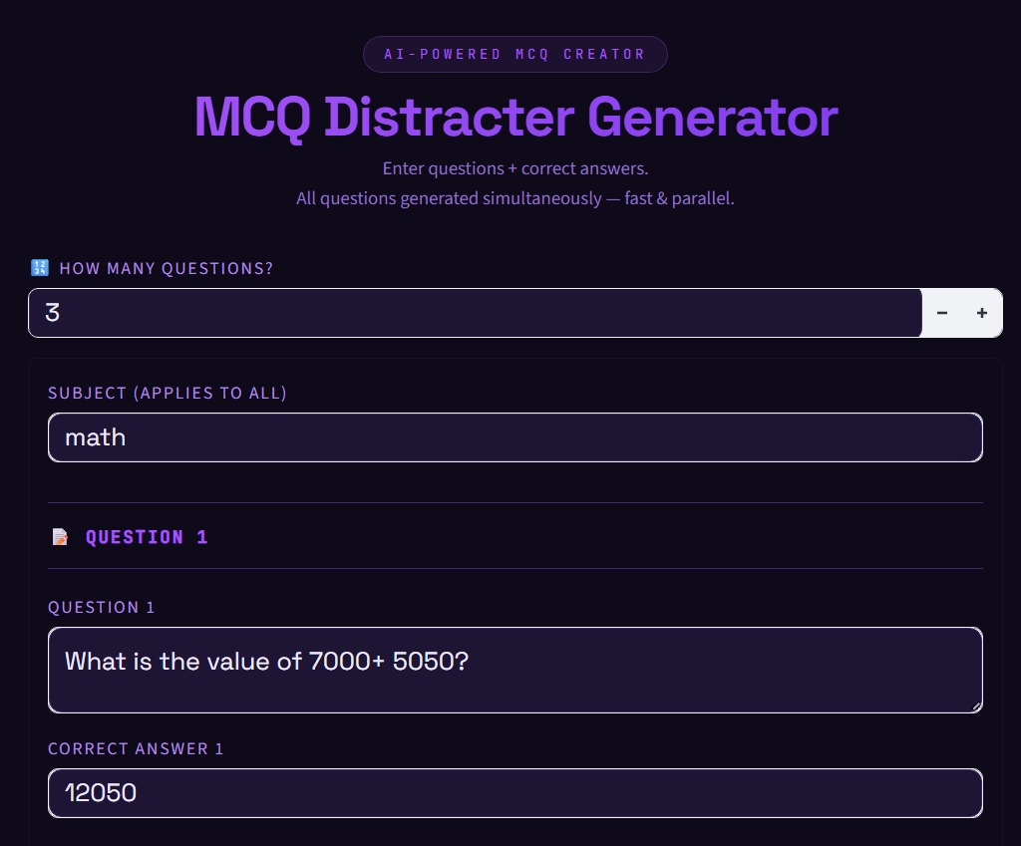

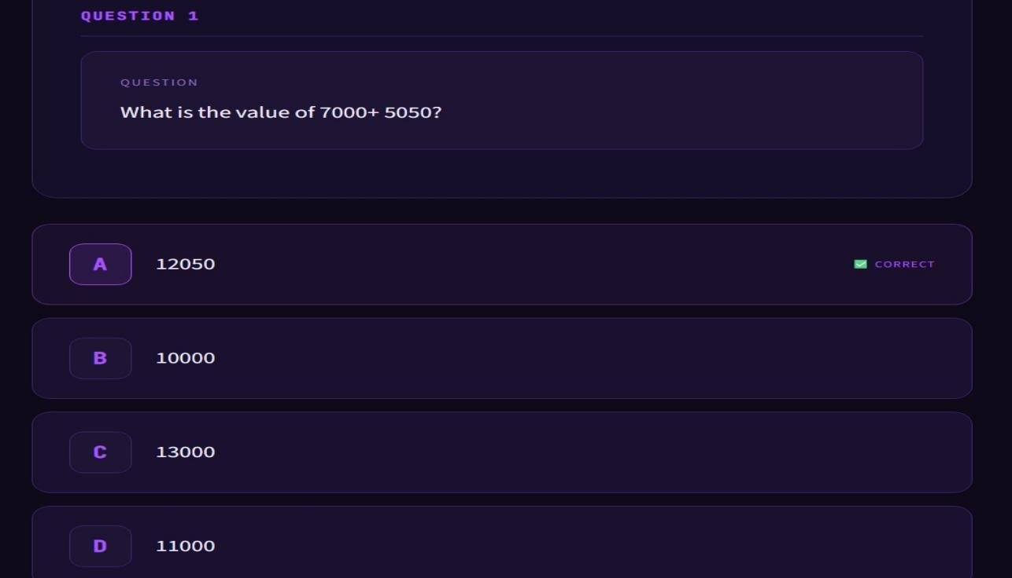
The correct answer is 12050, which is obtained by adding 7000 and 5050. The AI system analyzes the numerical structure of the problem and generates relevant distractors such as 10000, 13000, and 11000. These distractors are carefully chosen because they are close to the correct answer or result from common calculation mistakes, making them appear plausible to students. By providing such logically related alternatives, the system ensures that the generated MCQ is meaningful and effectively tests the learner’s understanding of basic arithmetic operations.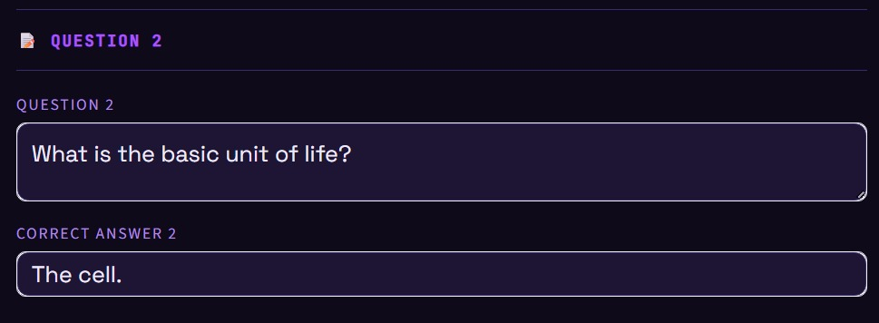
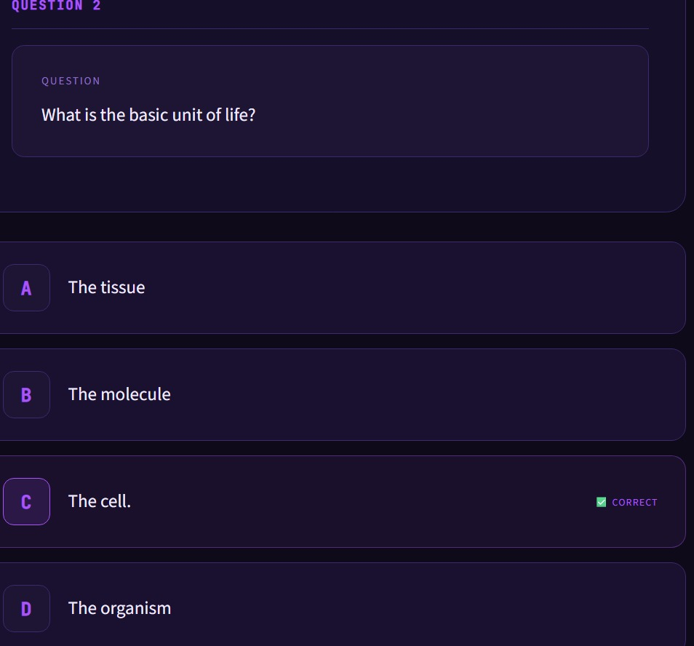

In this example, the AI MCQ Distractor Generator processes a biology question asking for the basic unit of life. The correct answer is identified as the cell. The system analyzes the conceptual context and generates plausible distractor options such as tissue, molecule, and organism. These distractors are carefully selected because they are closely related biological terms that students often confuse with one another. By including such conceptually similar alternatives, the system ensures that the MCQ is meaningful and effectively evaluates the learner’s understanding of fundamental biological concepts.

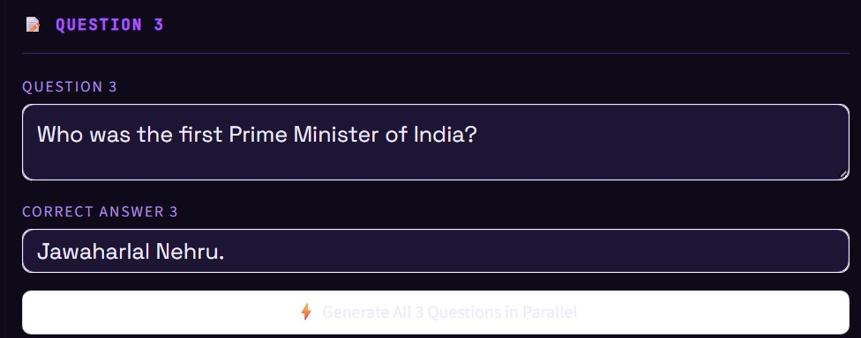

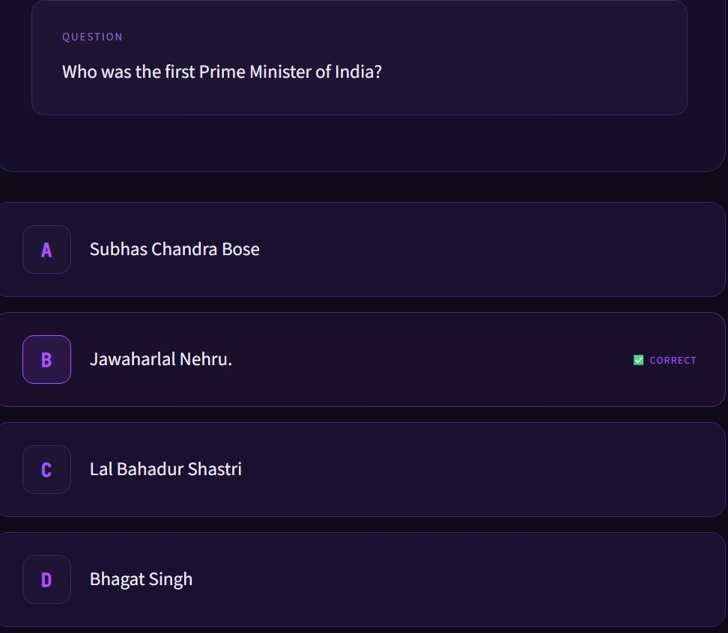

In this example, the AI MCQ Distractor Generator processes a history question asking who was the first Prime Minister of India. The correct answer is identified as Jawaharlal Nehru. The system analyzes the historical context and generates plausible distractor options such as Subhas Chandra Bose, Lal Bahadur Shastri, and Bhagat Singh. These distractors are carefully selected because they are prominent figures in Indian history and are commonly recognized by students, which makes them appear as reasonable alternatives. By providing such contextually relevant options, the system ensures that the MCQ is meaningful and effectively evaluates the learner’s knowledge of Indian history.

CONCLUSION

The AI MCQ Distractor Generator project demonstrates how Artificial Intelligence can significantly improve the process of creating multiple-choice questions for educational assessments. Traditionally, designing effective distractors requires significant time, expertise, and manual effort from educators. The proposed AI-based system automates this process by generating contextually relevant and meaningful distractors using Natural Language Processing and machine learning techniques.
Through the implementation of advanced AI models, the system analyzes the structure and meaning of questions to produce incorrect answer choices that closely resemble the correct answer while still remaining logically incorrect. This ensures that the generated distractors are challenging enough to accurately evaluate a student's understanding of the subject.
One of the major advantages of this system is its ability to reduce the workload of teachers and exam creators. Instead of manually designing distractors for every question, educators can simply provide the question and the correct answer, and the system will generate multiple plausible distractors automatically. This greatly improves efficiency, especially when preparing large question banks for competitive exams, online learning platforms, and academic institutions.
Another important benefit of the system is its consistency and scalability.

Since the AI model follows a structured approach to generating distractors, the quality of the options remains consistent across different questions. Additionally, the system can generate a large number of MCQs in a short amount of time, making it suitable for large-scale educational applications.
The integration of AI technologies such as Natural Language Processing, transformer-based language models, and semantic analysis ensures that the generated distractors maintain grammatical correctness and contextual relevance. The filtering and ranking mechanisms further enhance the quality of the output by selecting the most appropriate distractors from the generated candidates.
Despite its advantages, the system may still require human validation to ensure that the generated distractors perfectly align with educational standards. Future improvements can focus on enhancing the AI model's contextual understanding, supporting multiple languages, and integrating the system with existing educational platforms and learning management systems.
In conclusion, the AI MCQ Distractor Generator provides an intelligent and efficient solution for automated MCQ creation. By leveraging the power of Artificial Intelligence, the system simplifies the assessment design process, improves the quality of examination questions, and supports modern digital learning environments. This project highlights the potential of AI in transforming educational tools and demonstrates how technology can assist educators in delivering better learning and evaluation experiences.

